Mayor of Duvall’s bi-monthly update to the community

July 18, 2015

Mayor’s office:

At the last Council meeting there was public input and Council discussion about fireworks. The discussion will continue at the Committee of the Whole this week. We will have special guests Police Chief Carey Hert and Fire Chief David Burke join the discussion. In addition, we will have the microphones working so the audience can better hear the council.
The State of Washington passed a transportation package that will improve mobility throughout the region. One item with the package is $500,000 dollars for the Cole Clemens creek project. We had hoped there would be an additional $1,300,000 dollars for our Main Street, yet that appropriation did not survive the final package. I am confident the City will be able to complete the project without the additional funding.
The school district sent me a letter outlining their intent to purchase the property owned by the State of Washington via Lake Washington Technical College. They were the only party that expressed an interest in the property.
Finally, the City Administrator will start on Monday. He will be located in City Hall. Please stop by and wish him well on his new role.

City departments:

The City has five key departments, Police, Planning, Public Works, Finance and City Clerk. Each department works on key programs and projects. In addition we utilize the services of the City of Snoqualmie for IT.

Police:
Police Department:
Submitted by: Chief Carey Hert

- Chief Hert has been working on the 2016, preliminary police budget. Department budgets are due to finance on Tuesday, July 21st.

- Chief Hert and Fire Chief Burke met with our Public Safety Committee on Friday, July 17, 2015, to discuss options for sale and discharge of fireworks in Duvall, moving into future years. Further discussion will take place on Tuesday, July 21st at the regularly scheduled Committee Of The Whole.

- Chief Hert attended the Civil Service Commission Meeting on July 8, 2015. During this meeting, it was determined that our Police Department will be moving forward with Entry-Level Candidate Oral Boards, to establish an eligibility hiring list. The Oral Boards are tentatively scheduled for August 7th.

- Chief Hert and Commander Lewis have been working with our Evidence Clerk, S. Rowe, preparing for an evidence destruction, in order to free up space in our evidence vault. The destruction will take place next Friday, July 24, 2015.

- You may have noticed that our Police Facebook postings have not been as frequent, in the past several days. Sgt. Batiot is on vacation and will be returning the first part of August.

- Chief Hert and Commander Lewis have continued working with our local Fire Department on joint training for emergency situations, primarily focusing on Active Shooter Incidents. Chief Hert and Commander Lewis will be attending the Active Shooter Training Scenarios in Bellevue next week, as observers. We anticipate holding a tabletop exercise with our supervisory staff, as step 2 of the planning and preparation, in September.

- During the past two weeks, officers have responded to 118 calls for service, ranging from citizens assists, neighbor disputes, suspicious circumstances, unwanted persons and traffic offenses and accidents.

- As a reminder, our 2nd Annual National Night Out will be held on Saturday, August 8th!

Planning Department:
Submitted by: Lara Thomas, Planning Director

Current Development:
- Duvall Village –A notice of decision was issued for Duvall Village on on July 6. The project is now ready to submit construction drawings.
- Rio Vista – A notice of complete application was issued on July 8, and a notice of application (NOA) was issued on July 17. The public now has 14 days to provide public comments on the project. The NOA is one of three opportunities for the community to provide comments on this project. You can find documents to review online at http://www.duvallwa.gov/352/Planning-Projects.

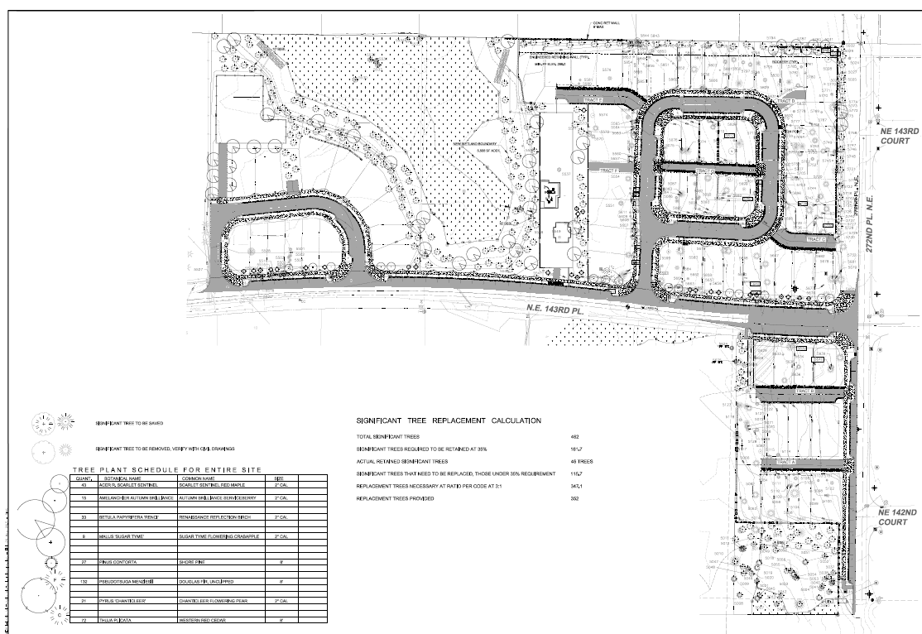
- Other- Planning is reviewing the Main Street Improvement Project, a city boundary line adjustment (BLA), and a planning departure application. Planning anticipates a BLA and subdivision to be submitted late July for Hower Hill.

Long Range:
- Watershed Plan –The Planning Commission and the City Council will host public hearings on the plan at the August 19 Planning Commission Meeting and the September 1 City Council Meeting. DRAFT WATERSHED PLAN. Please consider taking time to review the draft plan. http://www.duvallwa.gov/350/Watershed-Plan This plan will help guide the City on how it GROWS in the future. lara.thomas@duvallwa.gov.


Snoqualmie River
Floodplain

- 2015 Comprehensive Plan Update – The City is completing the Draft Environmental Impact State (DEIS) for the ten year update to our GROWTH plan. A public hearing will be held on September 2 at Planning Commission. The DEIS will be issued on August 17th with a 30 day public comment period. The illustration on the left represents developable and redevelopable land in Duvall as of 2015. The illustration on the right shows potential rezones in the the western portion of the city. The City is considering down zoning the orange area from 12 units per acre to 8 units per acre. The City is also considering rezoning areas zoned Mixed Use along the 143rd Corridor to residential (12-20 units per acre) and commercial.

Finance Department:

Submitted by: Dean Rohla, Finance Director

- Finance Director first day of work was July 7th.
- Setup Finance Director with online accounts, bank and investment signature cards, IT, phones, etc.
- Setting up investment accounts so that the bond that matured can be reinvested next week.
- Closed the fiscal month of June.
- Prepare and submit monthly sales tax report.
- Prepare and submit quarterly investment report.
- Prepare and submit quarterly financial report.
- Updating the 2016 budget salary worksheet. CPI numbers available 7/17/15.
- Prepare estimates of final 2015 revenues and taking a look at the 2016 estimated revenue.
- Preparing 2015 budget amendment for Council.
- Invoice for June services provided.
- July 20th payroll was processed.
- Processing A/P invoices for the July 21st council meeting.
- Processed payroll, leasehold, and excise taxes.
- Continuing to experience numerous challenges related to the Springbrook upgrade. (Utility Billing, Payroll and A/P Modules) Continue to work with customer support to resolve issues. This is progressing slower than the team would like.
- Revising the Utility Billing Procedures manual to update for the version 7.17 of Springbrook.
- Utility bills were sent out the last week of June. Still not able to export radio read meters into Sensus without getting error messages due to the Springbrook upgrade.
- Meter reading and Shut-off take place the week of 7/20-24.
- Assisting with Special Recycle Collection Event.
- Assisting City Clerk with large Public Information Request.

City Clerk
Submitted by; Jodi Wycoff, City Clerk

City Clerk:
Special Events:
- Sandblast, July 18th & 19th, submitted a revised application adding activities at the Depot Building to their event.
- SummerStage Concerts – McCormick Park on Wednesdays beginning July 8th through August 12th.
- Tour de Peaks bicycle event – July 18th

In General:
- Ms. Wycoff, along with admins from other departments attended a training on the City’s phone system and have made most of the necessary updates to the system due to recent staff changes.
- Ms. Wycoff has posted the job description for the Administrative Assistant (front desk position) on the City website and AWC JobNet. The closing date for applications is August 7th.
- Ms. Wycoff will be working with CivicPlus and other City staff to train on the Agenda Center module for the website. This change will provide greater efficiency in creating Council packets for the web. This new module will also help the City towards their goal of going paperless for packets and other correspondence between Council and Staff.
- Ms. Wycoff is in the process of securing a facilitator for Open Public Meetings Act and Public Records Act training for Council and Commission and Board members. The goal is to have this training completed by the end of the third quarter.

Recycling:
- The Annual Special Recycle Collection Event (SRCE) is scheduled for Saturday, July 18th. The flyers went out July 1st and there have been numerous inquiries about the event since then. We are hoping for yet another successful event. This event is fully funded by grants from King County Local Hazardous Waste Management Program and Solid Waste divisions.
- Ms. Wycoff could not locate a farm interested in taking the plastic plant pots this year so this station is replaced by a shredding truck. This new station will allow participants to bring up to two boxes of shredding per vehicle.

Public Works Department
Submitted by: Steve Leniszewski, Public Works Director

Generally speaking, PW management staff have been diligently working on the budget proposal for 2016. PW makes up a significant portion of the entire city budget and it is a large undertaking. We are scheduled to have the first draft completed next week.

Utilities:
- Storm drainage work began this week. Public works is performing our annual catch basin cleaning work. We have found significant savings by renting a vactor truck and utilizing city staff to run the equipment. Renting the equipment is estimated to cost $15,000 or less; we have utilized contractors to perform this work in the past at roughly three times the cost.

- PW maintenance staff repaired a large water system leak this week. The leak was discovered in the area of Third Ave. and Dorothy St. by staff and a leak detection specialist was brought in to pinpoint the exact location. The repairs were made in a day and only one home was affected.

- The City of Duvall purchases water wholesale from Seattle Public Utilities (SPU) for distribution to our customers. SPU has changed the water supply outlook from “good” to “fair”. SPU has not enacted water use restrictions but urges everyone to use water wisely. We are recommending that customers be conscious of how much water they use and please fix leaks as soon as possible if you have them. There are free leak test kits as City Hall for those interested. Please see the SPU website for more information (http://www.seattle.gov/util/MyServices/Water/AbouttheWaterSystem/WaterSupply/index.htm ).

- At the request of the Mayor, two “life ring” stations have been purchased and installed at the beach in McCormick Park. With the hottest June on record the use of the beach has been very high. These are for emergencies but please familiarize yourself with them if you get a chance. Please enjoy the beach in a safe manner and visit the County’s website for tips (http://www.kingcounty.gov/healthservices/health/injury/water/riversafety.aspx ).

- With the unprecedented dry weather we are running low on budget for the maintenance of green grass at the Big Rock Park fields. The proposed budget which was reduced for watering will not accommodate watering enough to maintain green grass. We are sorry for the inconvenience.

- Staff has submitted the Boundary Line Adjustment for the Tech Center Buildings and Yard. We will close on the parcels when the BLA is recorded (≈45 days).

Project / Engineering Activities:
- Public Works Staff is continuing to work on permitting and design activities for the Main Street South project.

- PW and Planning staff met with King County Metro this week regarding the “Put Your Community In Motion’ campaign (http://metro.kingcounty.gov/outreach/duvall/ ). King County will propose an MOU to the City in the coming month, another presentation will be made on the project. Please take the survey on their website to help identify Duvall’s transit needs.

- Public Works Staff is preparing an invitation for quotes on the NE Stephens Street Overlay project with minor paving alternates. There is some budget for the work however we do expect prices for the work we are requesting to be over our budgeted amount. City Engineer Boyd Benson will provide an update at the next City Council meeting.

- Public Works Staff continues to correspond with WSDOT, Utility Providers, and PCL contractors on the Coe Clemons Creek Culvert Replacement Project. Significant construction activity, and a 7 to 10 day full-time closure of SR-203 at the culvert crossing, will begin in late July and August. Nightly closures will occur until the projects estimated completion in September 2015. Please familiarize yourself with detour options and spread the word (http://www.wsdot.wa.gov/Projects/SR203/CoeClemonsCreekCED/DetourMap.htm )
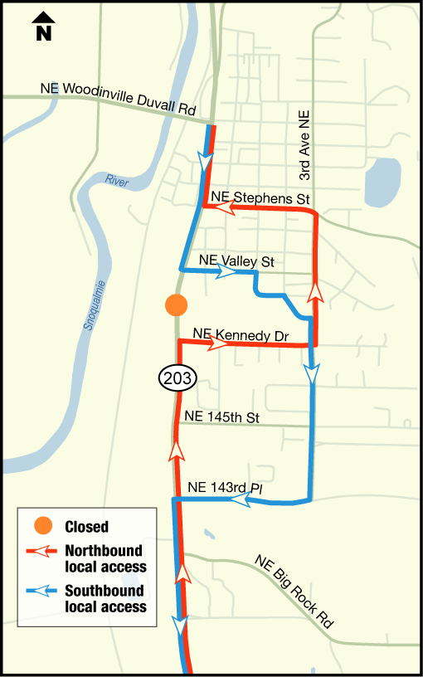

- SummerStage is off to a great start. Attendance is high and the new food truck and Rotary Sponsored beer / Wine garden seems to be a hit. Please check out a concert!
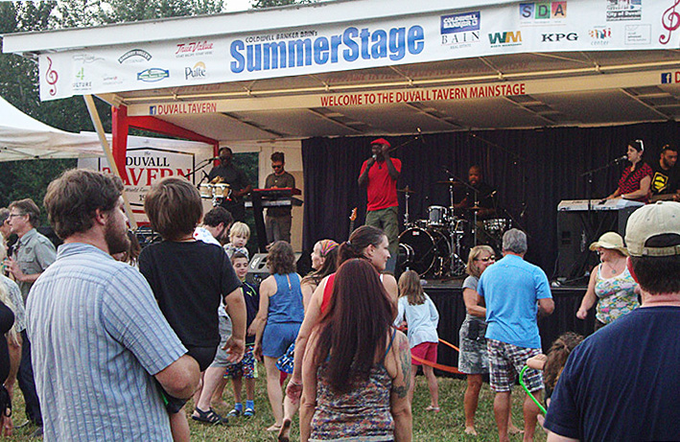

If you have any question about items listed herein please contact our office at any time to discuss.

IT Department:

Submitted by: PJ Rodriguez

Summary:
- On Going Projects Status
  - King County/Wave Broadband/School District/City of Duvall Shared Fiber Infrastructure
    - This project focuses on fiber infrastructure connecting City of Duvall locations/buildings
    - Working on enforcing the original requirements of the existing Franchise Agreement between Duvall and Wave/Summit/Millenium
    - Working with King County on providing redundancy and resiliency on all existing pathways
  - Desktop Replacement/Upgrade
    - In progress—negotiating cost with CDW for best price
  - Electeds and Senior Staff MS Surface Implementation
    - In progress—currently in process of inventory and build

IT Performance Metrics To Date:

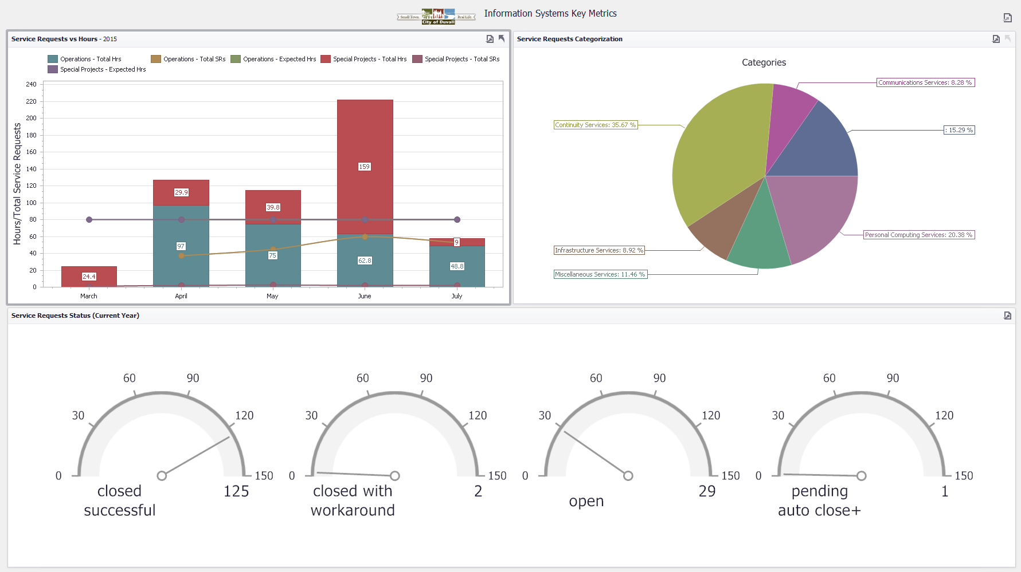

Mayor’s Office - Future Items:

I will begin transitioning myself away from the day to day operations of the City in the coming weeks. My role will change and I will focus more on community and regional engagement.

The summer concerts have been a huge hit with the beer/wine garden as well as a food truck. We started of this year with one food truck and based on its success, we should see additional trucks.
The big concert of the summer is this Wednesday with Austin Jenckes. It will be a very popular event, so please pack your chairs and a snack, come early and spend time with your neighbors and friends.

